Research Paper Outline Examples
This is an article with a few research paper outline examples. Creating an outline is the first
thing you should do before you start working on your research paper.
Research Paper Outline Examples
Once you've already decided what topic you will be writing about, the next thing you should
[1]
pay attention to is the scope of your paper or what you will be including in your discussion .
The broader your topic is, the more difficult it is to discuss your topic in full details. This is why
you should establish before hand the scope and limitations of your paper and this will be the

代写research paper：www.lxws.net
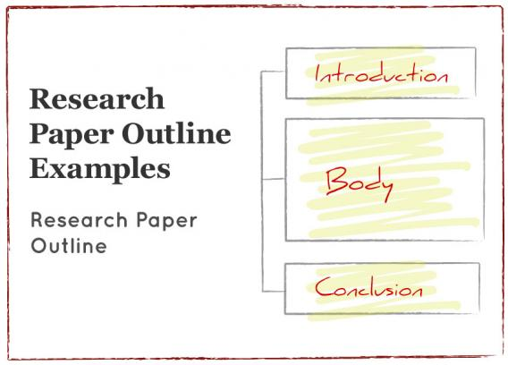

foundation of your research paper outline.
Basically, your outline will constitute three main parts namely the Introduction, the Body and
[2]
the Conclusion. But to make sure your paper is complete, consult your instructor for specific
parts he/she wants to be included in your research paper . Sample outlines for research
[3]

papers will be given later on. But first, let us discuss the main parts of your paper and what
information each should cover.
Introduction
The Introduction
[4] [5]
should contain your thesis statement or the topic of your research as

well as the purpose of your study. You may include here the reason why you chose the
particular topic or simply the significance of your research paper's topic. You may also state
what type of approach it is that you'll be using in your paper for the entire discussion of your
topic. Generally, your Introduction should state briefly all the major points of your topic your
readers will be reading about.
Body
The body of your paper is where you will be presenting all your arguments to support your
thesis statement. Please be reminded of the “Rule of 3” where you should find 3 supporting
arguments for each position you take. Start with a strong argument, followed by a stronger
one, and end with the strongest argument as your final point.
Conclusion
Conclusion
[6]
is where you form a summary of all your arguments and state your final stand.

Explain why you've ended up with the said conclusion.
Research Paper Outline Examples
As mentioned earlier, here are some sample outlines for research papers:
Sample #1
Thesis Topic:A Study on Factors Affecting the Infant Feeding Practices of Mothers in
Las Pinas City
I. Introduction
A. Statement of the Problem
B. Definition of Terms
C. Theoretical Framework
D. Methodology
1. Type of Research
2. Respondents
3. Questionnaire
E. Hypothesis
F. Review of Related Literature


G. Scope and Limitations
H. Significance of the Study
II. Body
A. Background of the Study
1. Benefits of Breastfeeding
2. WHO Recommendations
3. The International Code of Marketing of Breast Milk Substitutes
4. The Baby-Friendly Hospital Initiative
5. The Innocenti Declaration on the Protection, Promotion and Support of
Breastfeeding
6. National Situationer
7. The Milk Code
8. BFHI in the Philippines
9. Milk Code Violations
10. Formula Feeding
11. Factors Influencing the Decision Regarding Infant Feeding Method
12. Area Situationer
B. Presentation and Analysis of Data
1. Socio-economic Demographic Profile of Mothers
2. Information Regarding Current (Youngest) Infant
3. Current Infant Feeding Practices of Mothers
a. Exclusive Breastfeeding
b. Mixed Feeding
c. Formula Feeding
4. Previous Infant Feeding Practices
5. Maternal Knowledge
6. Correlation Tests
III. Conclusion
A. Concluding Statement
1. Analytical Summary
2. Thesis Reworded
B. Recommendations
Sample #2
Topic:Asbestos Poisoning
I. Introduction
A. Definition of Asbestos Poisoning
B. Significance of the Study
C. Definition of Terms
II. Body
A. Symptoms of Asbestos Poisoning
B. Effects of Asbestos Poisoning
C. Treatments
III. Conclusion
A. Conclusion
B. Recommendations
1. How to Deal with Asbestos Hazards


Sample #3
Topic: Shakespeare Adapted from AResearchGuide.com .
[7]
I. Introduction
II. Body
A. Early Life
1. Family
a. Father
b. Mother
2. Marriage
a. Life of Anne Hathaway
b. Reference in Shakespeare's Poems
B. Works
1. Plays
a. Tragedies
i. Hamlet
ii. Romeo and Juliet
b. Comedies
i. The Tempest
ii. Much Ado About Nothing
c. Histories
i. King John
ii. Richard III
iii. Henry VIII
2. Sonnets
3. Other Poems
C. His Later Years
1. Last Two Plays
2. Retired to Stratford
a. Death
b. Burial
III. Conclusion
A. Analytical Summary
B. Thesis Reworded
C. Concluding Statement

