APA Sample Paper: Title Page
Personality and Birth Order
1
The title page has
1" margins and is
double-spaced.
In the header,
leave 5 spaces
between the
shortened title and
the page number.
Personality and Birth Order: First-Borns and Later-Borns
Rosa Velasquez
Include your
name, class,
instructor,
and date.
Psychology 1
Professor Nguyen
May 21, 2004
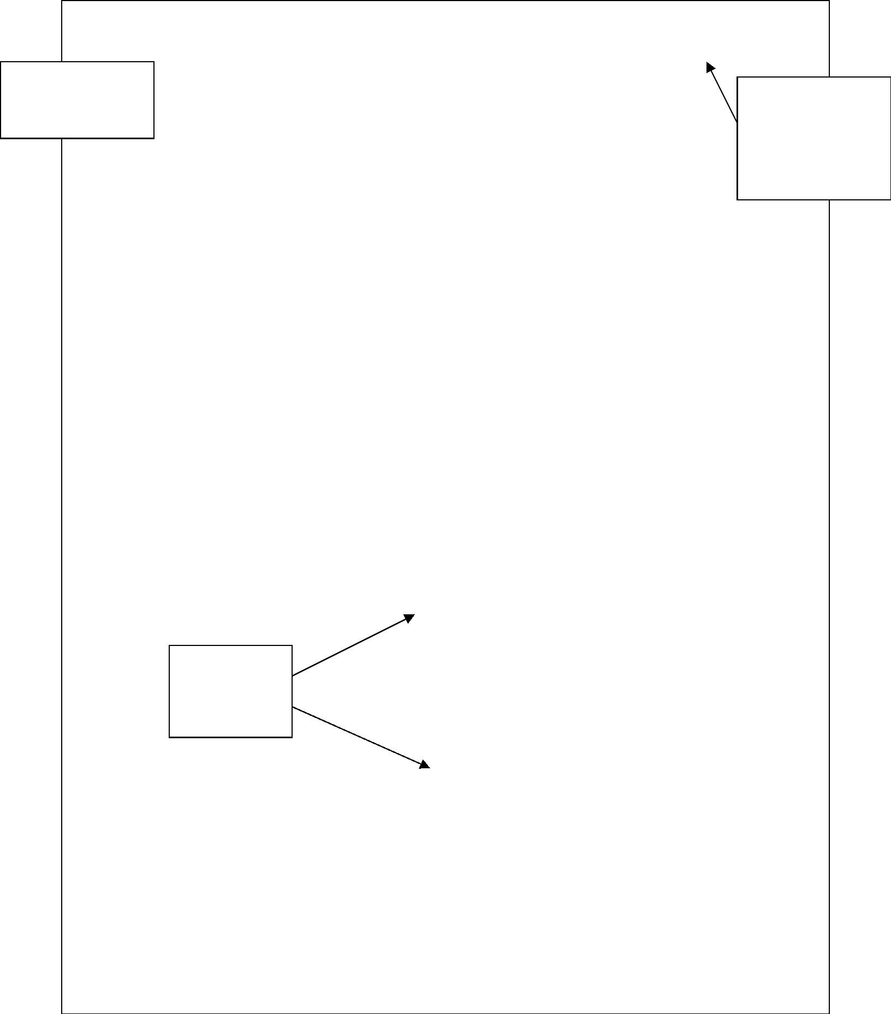

APA Sample Paper: Text
Use 12 pt.
Times Roman
or Courier.
Personality and Birth Order
Personality and Birth Order: First-Borns and Later-Borns
2
Use 1" margins and
double-space text.
Does birth order have any effect on personality? The naysayers
including psychologists Seff, Gecas, and Frey (1993) argued that
"research on birth order effects has been remarkably inconsistent and
inconclusive with regard to various personality and behavioral
outcomes" (Introduction section, ¶ 4). MIT historian Sulloway (1996)
In-text citations
consist of the
author's name
and the year of
publication.
When quoting,
give the page
number for
print sources
and the
Authors are
referred to by
last name
throughout the
paper.
paragraph
Within the text,
capitalize the
major words in
a title of a book
or article.
number, or as in
this case the
heading and
paragraph
number, for
electronic
disagreed. In his book, Born to Rebel, he offered proof of the
relationship between birth order and personality.
Researching the lives of historical figures, Sulloway (1996)
observed that later-borns tend to champion liberal or unconventional
ideas while first-borns do not: "Later-borns were more likely than
first-borns were to support each of the 61 liberal causes . . . surveyed,
from the Protestant Reformation to the American civil-rights
movement" (as cited in Cowley, 1996). Rule-breaking later-borns
include Susan B. Anthony, Mahatma Gandhi, Martin Luther King, Jr.,
and Charles Darwin. In contrast, first-borns defend the status quo
(Sulloway, p. 79). Naturalist Louis Agassiz fits this mold. The most
influential naturalist of his day, first-born Agassiz staunchly opposed
sources.
When introducing
sources, use the
past tense or
present perfect
tense (e.g., has
observed).
Use an ellipsis (. . .)
when omitting
original material.
Since this
electronic
source has no
page,
paragraph
numbers, or
headings, no
pagination is
given.
For a secondary
source in which
one author is
being quoted or
paraphrased in
another author's
work, name the
original work, but
cite the secondary
source.
Since Sulloway was already
cited in this paragraph, no date
is needed. However, if
Sulloway is cited in a new
paragraph, the first in-text
citation should include the date.
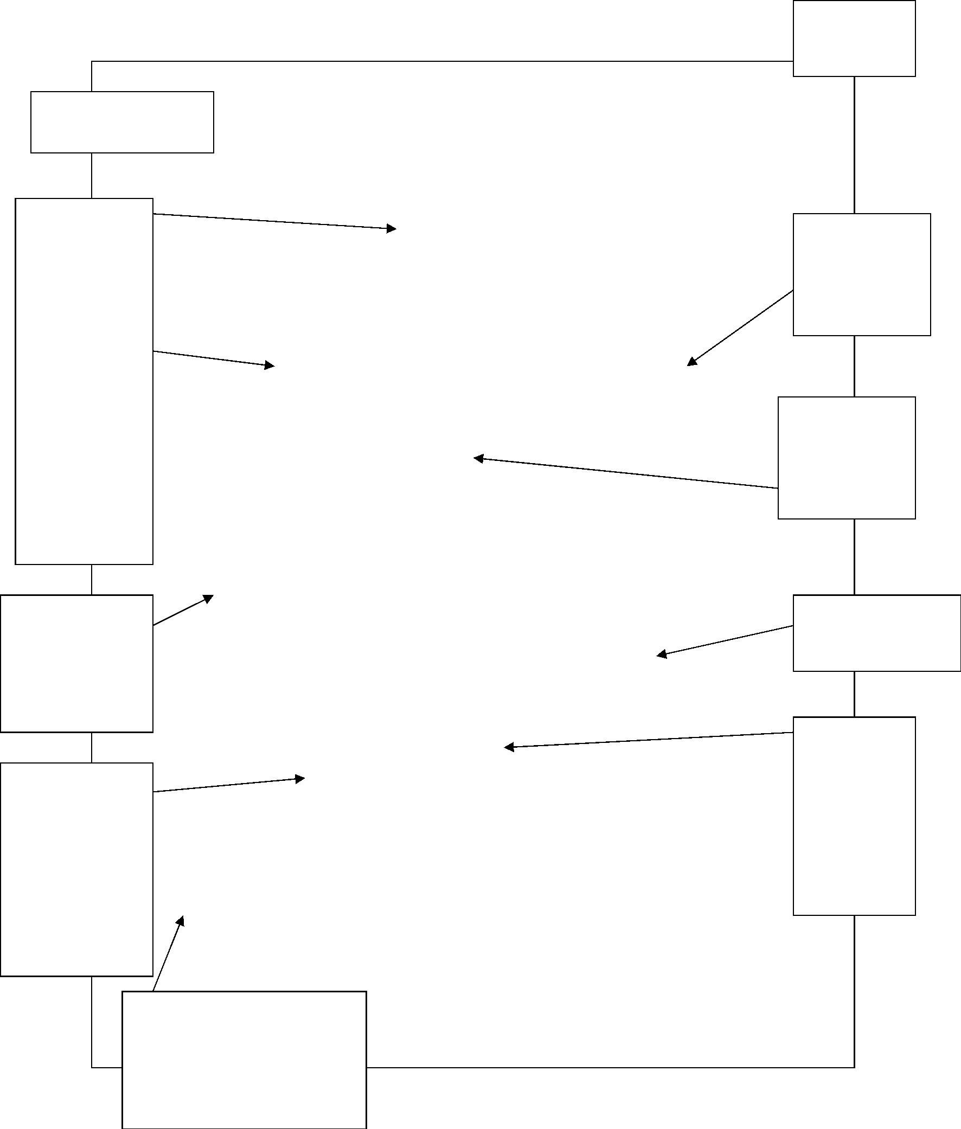

Personality and Birth Order
3
Darwin's radical notions about biological change:
When Darwin proposed a revolutionary solution--that all
nature's variety stems from a simple process that preserves
useful variations and discards harmful ones--the authorities
A quotation of
40 words or
more starts on a
new line and is
indented 1/2" or
5 spaces.
were appalled. "A scientific mistake" thundered Louis Agassiz,
. . . "untrue in its facts . . . and mischievous in its tendency."
Quoted material within
a block quotation are
enclosed with double
quotation marks.
(Cowley)
In a block quotation,
end punctuation comes
before the in-text
citation.
APA Sample Paper: References
Personality and Birth Order
References
5
Sources are listed
in alphabetical
order by author's
last name. If
The reference
list begins on
a new page.
Cowley, G. (1996, Oct. 7). First born, later born. Newsweek, 128.
Retrieved May 21, 2004, from Expanded Academic ASAP
database (Article A18722426).
there is no
author, move the
publication date
after the title and
alphabetize by
the first major
word in the title.
Seff, M. A., Gecas, V., & Frey, J.H. (1993). Birth order, self concept,
and participation in dangerous sports. The Journal of
Psychology, 127. Retrieved May 23, 2004, from Expanded
Academic ASAP database (Article A14110698).
The entire reference
list page is double-
spaced and has one-
inch margins.
The second line
of each entry is
indented 1/2" or
5 spaces.
Sulloway, F. J. (1996). Born to rebel. New York: Pantheon.
In the reference list, capitalize
only the first word in the title and
subtitle of a book or article.
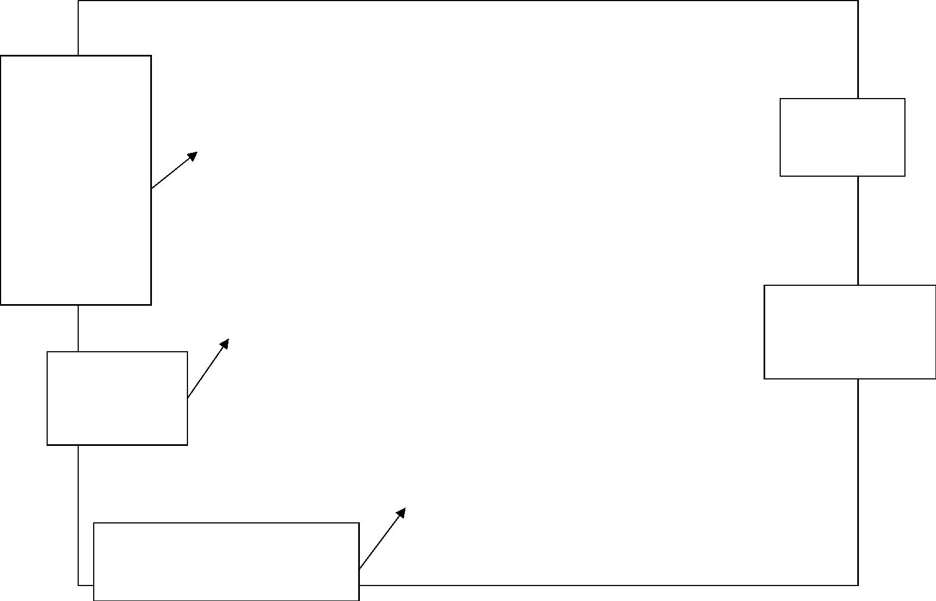
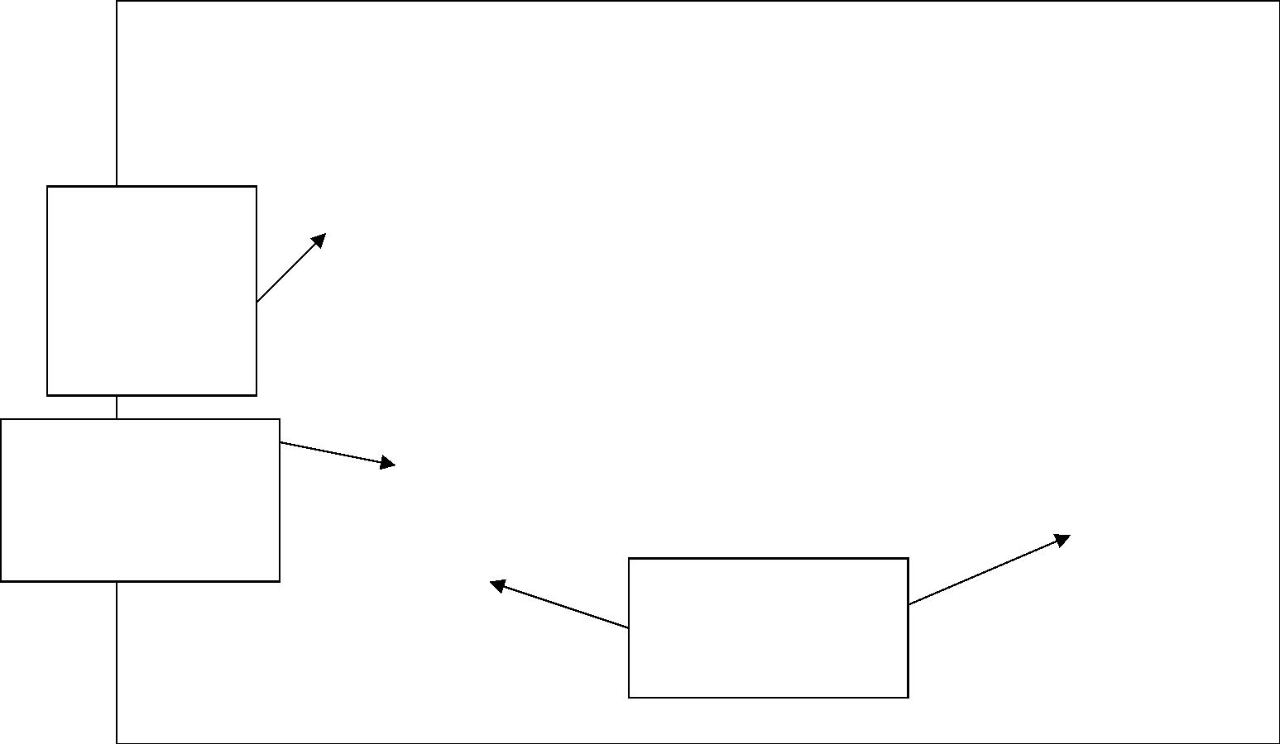

Additional Resources
For additional help with APA style documentation consult the following
resources in the Writing Center.
A Writer's Reference
Writing Center Handout: APA Style—Reference List/In-text
Publication Manual of the American Psychological Association
Purdue University's OWL is another excellent source of information on
APA.
http://owl.english.purdue.edu/handouts/research/r_apa.html
http://owl.english.purdue.edu/workshops/hypertext/apa/index.html

